Paul D. Casey Bio/Introduction
www.paulcasey.org
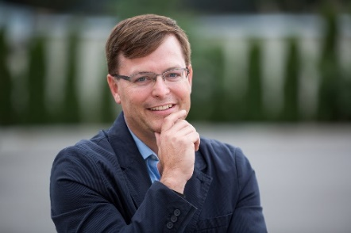

Originally from Chicago, Paul has now been a professional speaker for over 25 years (giving almost 300 presentations in the past 4 years), and he is one of the leading authorities in leadership and personal growth—especially time management—helping people take back their calendars and restore sanity to their lives. He has spoken for organizations like McDonalds, Subway, Lamb Weston, Northwest Public Power, and Autozone—and among the 80 leaders he coaches per year, 25 of them lead at Pacific NW National Laboratories. Paul has a Master’s degree in education, and has been an educator/administrator/Chief Operating Officer in 5 non-profit organizations. He has coached leaders for over 3,300 hours and is an ACC-certified coach with the International Coaching Federation, as well as a Master Trainer, and a member of the National Speakers Association. He was honored as an Entrepreneur of the Year in the Tri-Cities in 2021.

Through his company, Growing Forward Services, Paul has partnered with his corporate and individual clients to transform their vision, their habits, and their lives. Currently, Paul carries out his mission of sparking breakthrough success by contributing daily inspirational growth messages on local radio, other people’s podcasts, and via social media. Also, he has inspired thousands of individuals and leaders to grow forward through his seminars, team-building off-site retreats, one-to-one self-leadership coaching, and as a keynote speaker. Paul has written 5 books: The Static Cling Principle (on habits and mindsets), Maximizing Every Minute (on time management), Leading the Team You’ve Always Wanted, Leading with Super-Vision, and his newest book: Leading through the Dark Waters of Conflict. He interviews local leaders in his podcast: the Tri-Cities Influencer and national leaders on his podcast: Grow Forward Today.

Paul is married to Lovely Laura, has two young adult children named after state capitals, owns a new puppy named Gizmo, and has lived in the Tri-Cities, WA, for over 20 years. For fun, he enjoys golfing and hiking—and orange slices—and he reads about 40-50 books per year.

